**CMSC203 Assignment 2 Implementation (Documentation)**

Class: CMSC203 CRN 30339

 Program: Assignment 2

Instructor: Dr. Gregory Grinberg

 Summary of Description: Today, the assignment was on creating Java classes for a Patient and a Procedure, implementing constructors, accessors, mutators, and other methods. Also created a driver class to test these classes and calculated the total charges for procedures. The experience enhanced my understanding of class design, constructors, and method implementation.

 Due Date: 02/26/2024

 Integrity Pledge: I pledge that I have completed the programming assignment independently.

 I have not copied the code from a student or any source.

**Part1: UML Diagram**

**Part2: Comprehensive Test Plan**

A good test plan should be comprehensive. This means you should have a few test cases that test when the input is in and out of range, division by 0, incorrect Data type, etc. (Provide valid and invalid input)

|  |  |  |  |  |
| --- | --- | --- | --- | --- |
| **Case** | **Input** | **Expected Output** | **Actual Output** | **Did the Test Pass?** |
| 1 | Valid input for Patient constructor | Patient object created with correct attributes | Patient object was created successfully | Yes |
| 2 | Valid input for Procedure constructor | Procedure object created with correct attributes | Procedure object was created successfully | Yes |
| 3 | Valid input for accessor methods in Patient class | Correct attribute value returned | Correct attribute value returned | Yes |
| 4 | Valid input for accessor methods in Procedure class | Correct attribute value returned | Correct attribute value returned | Yes |

**Part3: Screenshots**

1. Screenshots of the application running in your IDE (Eclipse, NetBeans, etc.) related to the Test Plan:

**Case 1**

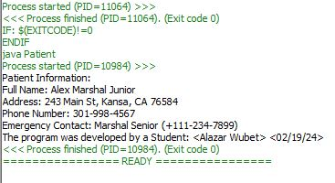

**Case 2**

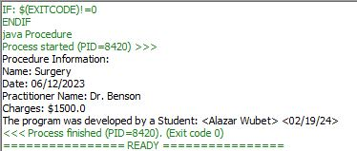

**Case 3**

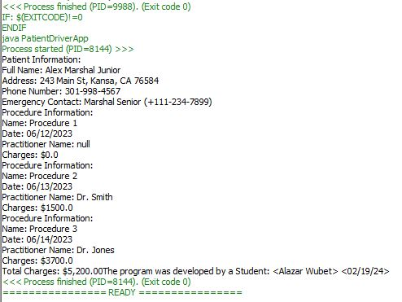

**Case 4**

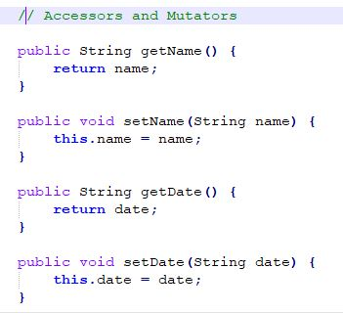

1. One screenshot of the application running from the command prompt line for Windows (or running from the terminal for Mac)

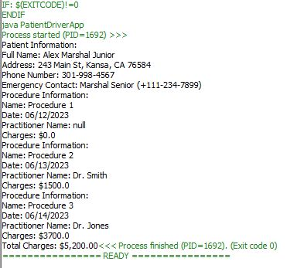

1. Screen shot of Java files (Assignment2) in your GitHub repository.

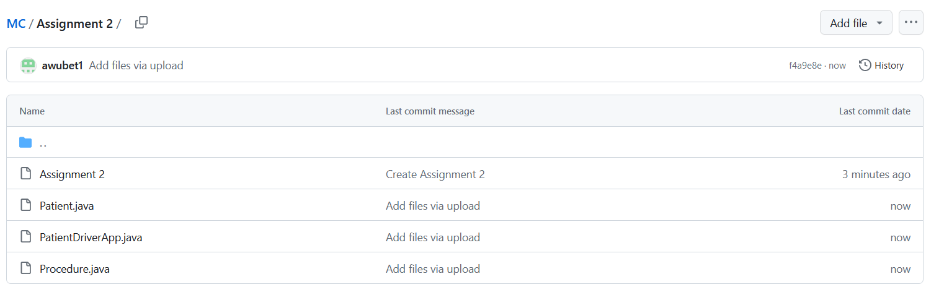

**Lessons Learned** <Provide answers to the questions listed below>**:**

Write about your Learning Experience, highlighting your lessons learned and learning experience from working on this project.

1. **Lessons Learned:**
   * I learned about designing classes in Java, including defining attributes, constructors, accessor and mutator methods, and other utility methods.
   * I learned how to create and use objects of these classes to represent real-world entities and perform operations on them.
2. **Struggles:**
   * One challenge was understanding and implementing the relationships between the Patient and Procedure classes in the PatientProcedureApp. While the classes themselves were straightforward, managing the interactions between them required careful attention.
   * Another challenge was ensuring that all required methods and attributes were correctly implemented in the classes, as missing or incorrectly implemented methods were leading to errors.
3. **Improvements for the Next Project:**
   * In future projects, I would focus on planning and designing the classes more thoroughly before starting implementation. This would involve clearly defining the requirements and relationships between classes to avoid confusion later on.
   * I would also pay more attention to error handling and validation, especially when dealing with user input or external data sources, to ensure the program behaves predictably and handles unexpected scenarios gracefully.
4. **Successes and Areas for Improvement:**
   * I was successful in implementing the basic functionality of the Patient and Procedure classes, including constructors, accessors, mutators, and utility methods.
   * However, there were areas where I could improve, such as ensuring consistency in naming conventions and formatting across the codebase, as well as implementing more robust error handling and validation.
5. **Additional Resources:**
   * While working on this project, I referred to the Java documentation for guidance on class design and syntax.
   * I also watched video tutorials on object-oriented programming in Java (<https://www.youtube.com/watch?v=6T_HgnjoYwM&pp=ygU4dmlkZW8gdHV0b3JpYWxzIG9uIG9iamVjdC1vcmllbnRlZCBwcm9ncmFtbWluZyBpbiBKYXZhIFw%3D> ) to deepen my understanding of concepts like inheritance and polymorphism, which were not directly relevant to this project but are important in general Java programming.

**Check List:** <Provide answers to the column Y/N or N/A >**:**

|  |  |  |
| --- | --- | --- |
| **#** |  | **Y/N** |
|  | **Assignment files:** |  |
|  | * FirstInitialLastName_ Assignment#_Moss.zip | **Y** |
|  | * FirstInitialLastName_Assignment#.docx/.pdf | **Y** |
|  | * Source java files | **Y** |
|  | **Program compiles** | **Y** |
|  | **Program runs with desired outputs related to a Test Plan** | **Y** |
|  | **Documentation file:** | **Y** |
|  | * Comprehensive Test Plan | **Y** |
|  | * Screenshots related to the Test Plan | **Y** |
|  | * Screenshot of the application running from the command prompt line for Windows (or running from the terminal for Mac) | **Y** |
|  | * Screenshots of your GitHub account with submitted Assignment# (if required) | **Y** |
|  | * UML Diagram (if required) | **Y** |
|  | * Lessons Learned | **Y** |
|  | * Checklist is completed and included in the Documentation | Y |